EI CLASS 1 (28/07/2025) GIT FUNDAMENTALS

LINUX KEYWORDS:

1. Provides the list using “ls”
2. Opens desktop using cd-change directory
3. Create new folder using “mkdir foldername”
4. Go to the folder using “cd”
5. Create new file “touch filename”
6. Use “ls” to list the files

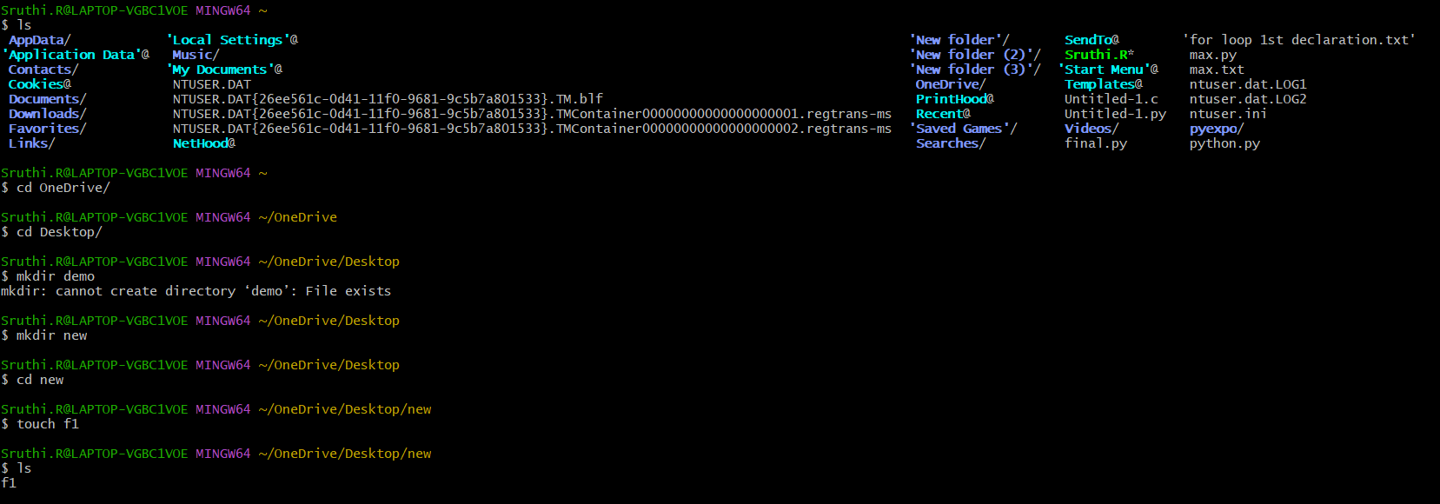

1. Use text editor “VIM” to write
2. “:wq!” to save and quit the file
3. Use “cat” to display the file

GIT KEYWORDS:

1. Use “git init” to initialize.
2. “git add .” to track
3. “git status”
4. “git commit -m “message”
5. “git log”
6. “git push -u origin master

